Two Dimensional Transformations

Aim
To perform basic two dimensional (2D) transformations such as Translation, Scaling, Rotation, and Reflection on a given 2D object.

Introduction (Theory)
Two Dimensional Transformations are operations used in computer graphics to change the position, size, orientation, or shape of an object in a 2D plane.
These transformations are performed using matrix operations on the coordinates of the object.
The commonly used 2D transformations are:
- Translation
- Scaling
- Rotation
- Reflection

(a) Translation

Definition
Translation is the process of moving an object from one position to another without changing its size or orientation.

Translation Formula
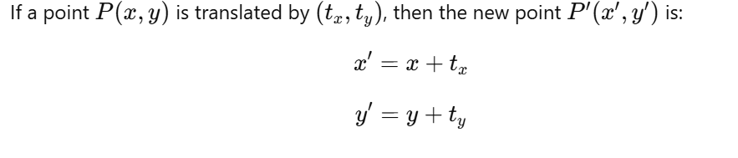

Translation Matrix
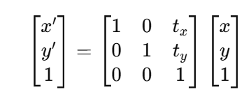

Effect
- Object shifts left, right, up, or down
- Shape and size remain unchanged

(b) Scaling

Definition
Scaling is the process of changing the size of an object by multiplying its coordinates with scaling factors.

Scaling Formula
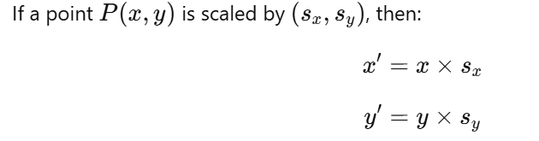

Scaling Matrix
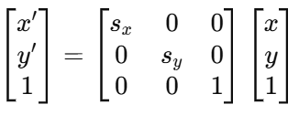

Effect
- sx>1,sy>1s_x > 1, s_y > 1sx​>1,sy​>1: Object enlarges
- sx<1,sy<1s_x < 1, s_y < 1sx​<1,sy​<1: Object shrinks

(c) Rotation

Definition
Rotation is the process of turning an object about a fixed point (origin or pivot point) by a certain angle.
Rotation Formula
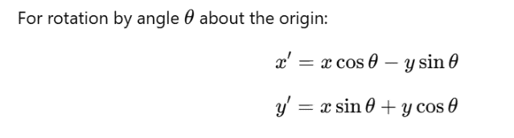

Rotation Matrix
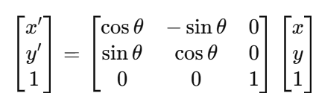

Effect
- Object rotates clockwise or anticlockwise
- Shape and size remain unchanged

(d) Reflection

Definition
Reflection is a transformation that produces a mirror image of an object about a reference axis.

Reflection about X-Axis

Formula

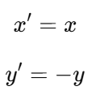

Matrix
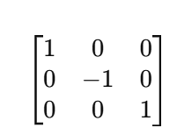

Reflection about Y-Axis

Formula

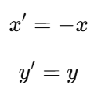

Matrix

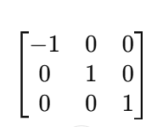

Effect
- Produces mirror image of the object
- Orientation changes, size remains same

Conclusion
Two dimensional transformations are essential operations in computer graphics. They help in manipulating objects by changing their position, size, orientation, and direction using mathematical matrices.

